|  |
| --- |
| AJJ BNB Executive Summary |
| Group Member Names: Ashley Pergoliti (s5311775)Jonas Sajonas (s5284977)2810ICT Software TechnologiesDate: |

# Abstract

This document investigates the functionalities of the AJJ BNB application, which was designed for efficient data visualisation through charts and tables over 12 months using public Sydney Airbnb data. The application successfully generates data such as listing counts, price distributions, keyword searches correlated with amenities, cleanliness keyword searches in comments, and house listing ratings, all within specific Sydney suburbs. However, while it effectively produces tabulated results based on location and time specifications, it requires diagrammatic representations. Furthermore, some generated graphs do not allow for date selection, resulting in extensive data presentation, as seen in the price distribution charts. Furthermore, the application could benefit from improved data limitation features and date selection capabilities across all use cases for a more refined user experience and data presentation.

# Introduction

This report outlines the functionalities that are implemented within the application software. It emphasises its ability to display five distinct data types, with an additional option for visualising the fifth data type using a chart. The first three analyses extract data within user-specified date ranges and present the retrieved information in a tabular format.

This layout design allows users to manually select, view, and use data as they see fit. Furthermore, the software includes two chart views to elucidate discernible trends within the data while intentionally omitting date parameters to limit the search scope. The retrieved data is naturally flexible, allowing further user-driven customisation within the software to meet specific analytical needs. The subsequent analysis outlines the specifics of the data obtained through these processes.

# **Analysis 1: Display Listing for a Suburb**

The "Display Listings for a Suburb" feature retrieves and displays relevant information from the database in a tabular format. This function's date range was set from January 1, 2019, to January 1, 2020. The data is extracted using predefined parameters from a concise, built-in table chosen by the team to highlight essential listing details for the application. Upon successful data retrieval, a new window is opened, displaying a table containing listing details such as, but not limited to, listing names, URLs, and locations. Figures 1 and 2 below depict the interface and the result.

Figure 1: AJJ BNB Interface for Suburb Listings

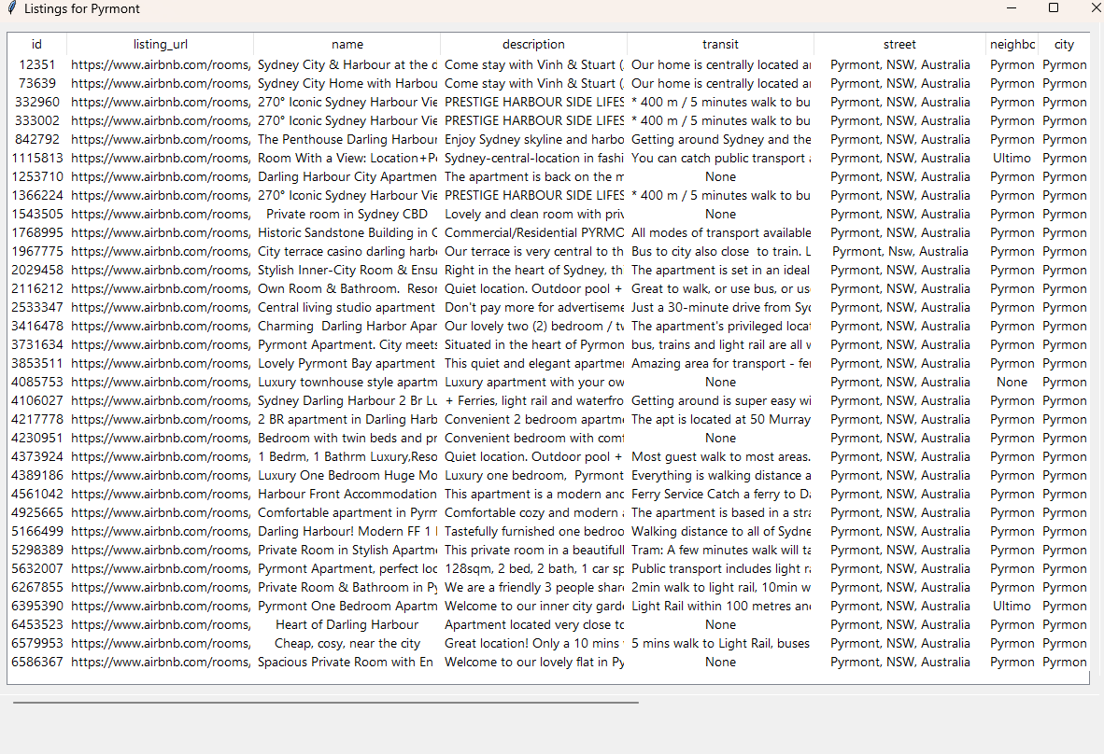

Figure 2: Listings for Pymont for a 12-month period.

# **Analysis 2: Display Pricing Chart**

The "Display Price Distribution for Balmain" feature demonstrates that from January 1, 2019, to January 1, 2020, listing prices in Balmain trended towards the higher end, with fewer properties available at lower prices. Figure 4 depicts the total listings for the past 12 months, arranged from cheapest to most costly.

Figure 3: Display Price Distribution

Figure 4: Display Price Distribution for Balmain

# **Analysis 3: Display Search Records**

Users can use the "Display Search Record Interface" functionality to choose data within specific date ranges and launch keyword searches connected to the amenities table. Using the interface, a search with the keyword "pool" was performed on shortlists from January 1, 2019, to January 1, 2020. The search produced tabulated records displaying listings with pools listed as features. The following figures explain the method and outcomes of this keyword search functionality. Figures 5 and 6 show the functionality of Display Records.

Figure 5: Display Search Keyword “Pool”

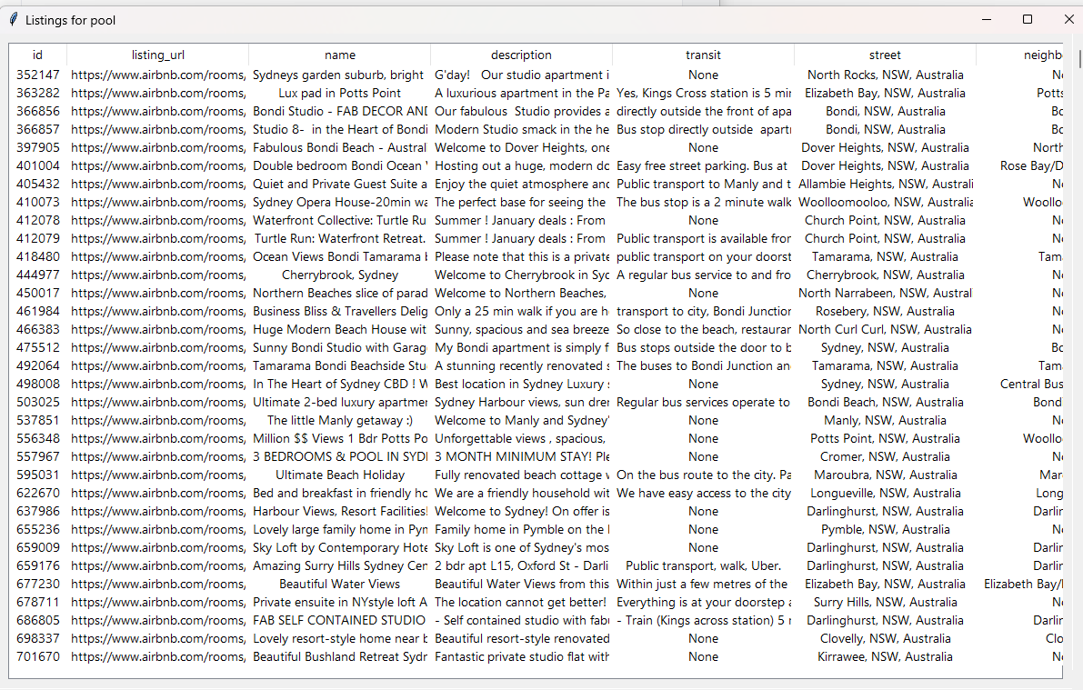

Figure 6: Display Search Keyword Table

# **Analysis 4: Display a Chart of Suburbs according to Cleanliness**

The "Display Cleanliness Records Interface" allows users to select a suburb and receive a tabular list of suburb records referencing cleanliness-related phrases. This table lists the dates of comments, reviewers, and cleanliness-related remarks, containing all results in the database without regard to date constraints. Keywords utilised include clean, unclean, dust, neat, and others. Figure 8 shows the results of the queries.

Figure 7: Display Cleanliness Records Interface

Figure 8: Cleanliness Record Table

# **Analysis 5: Display Listings in a Suburb by Ratings**

The "Display Listings in a Suburb by Ratings" feature provides a table of listings for a user-selected suburb using pre-selected parameters. Users can examine either a condensed or comprehensive version of the table. This tool, which works without regard to time, generates a ratings-based listings table for the selected suburb, aggregating all available data for that area.

Figure 9: Display Listings by Ratings

Figure 10: Display Listings by Ratings in Tabular form

# **Analysis 6: Display Chart of Listings in a Suburb by Ratings**

The "Display Chart in a Suburb by Ratings" tool creates a pie chart for analysing listings in a specific suburb, focusing on those with ratings greater than 75. This visualisation groups and presents the total number of high-rated listings, providing an instant overview of the suburb's rating-based listing distribution. Figure 11 depicts the diagram created.

**

Figure 11: Display Listings by Ratings in a Chart